CS Bridge Module 12 Recursions Part 3

1. Recursions - Part 3

1.1 CS Bridge: Recursions
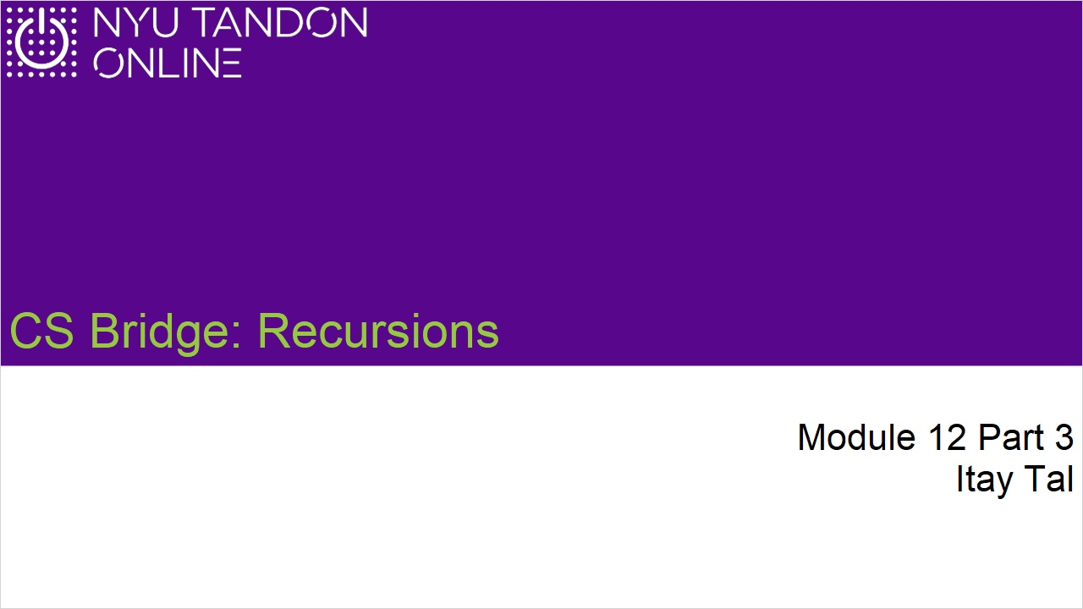
Notes:

1.2 Factorial
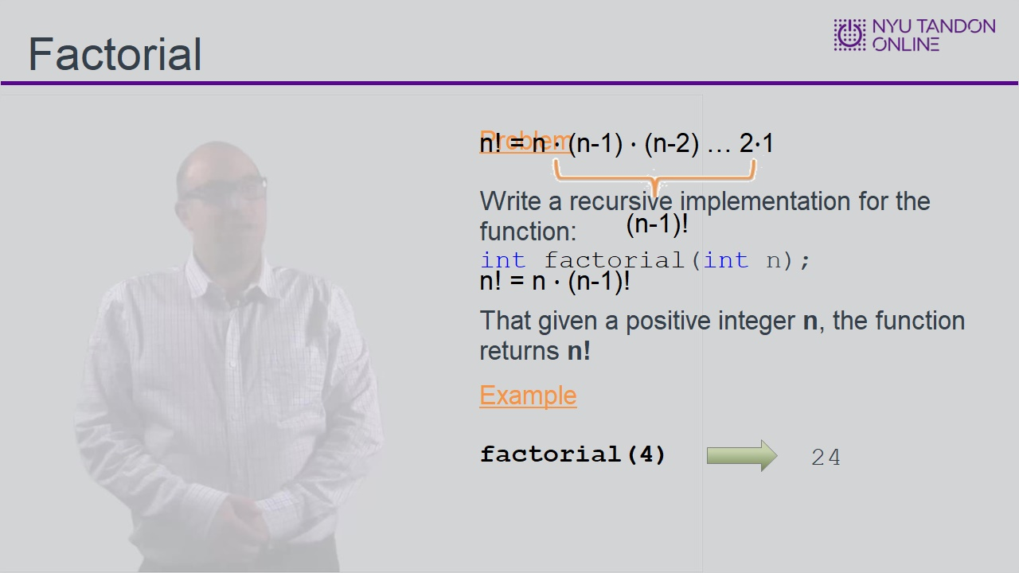
Notes:

1.3 Factorial Implementation
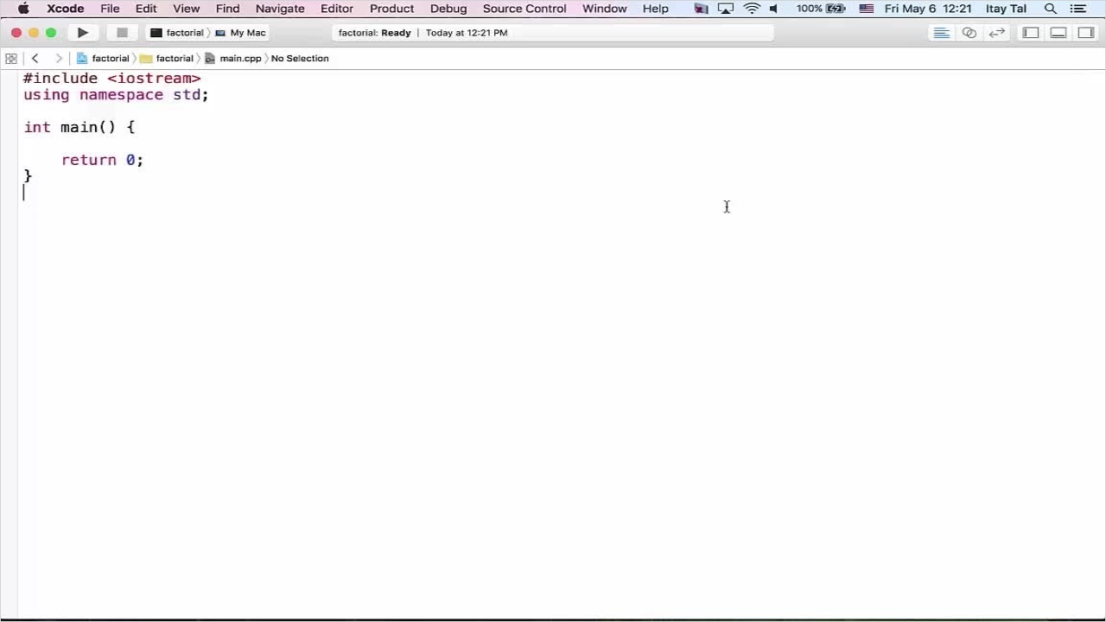
Notes:

1.4 Are All of the Digits Even?
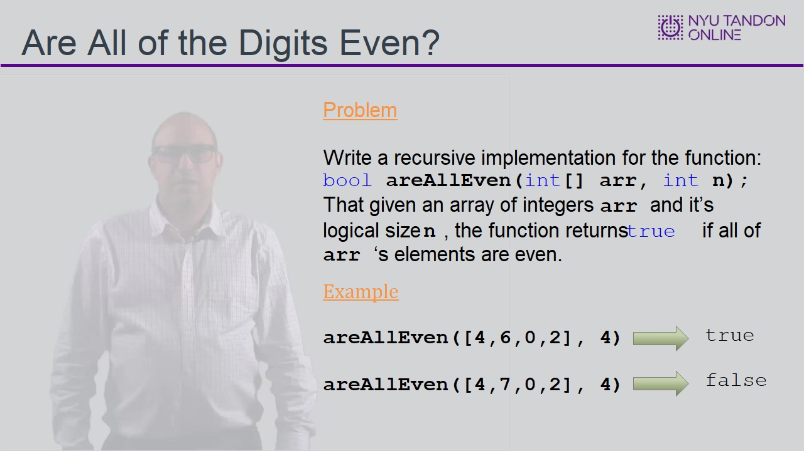

1.5 Are All of the Digits Even? Implementation
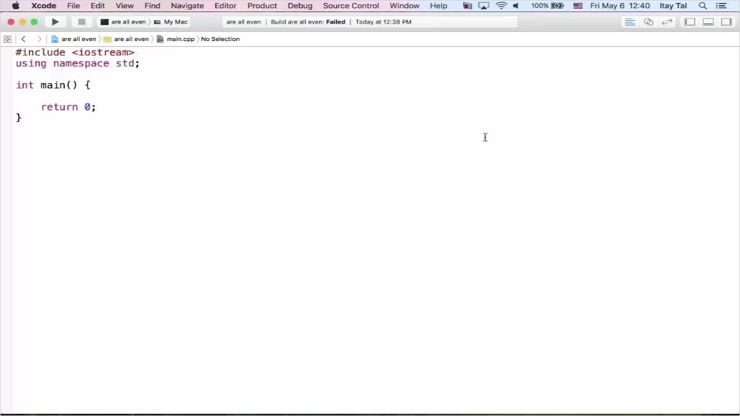
Notes:

1.6 Knowledge Check
(Multiple Choice, 10 points, 4 attempts permitted)
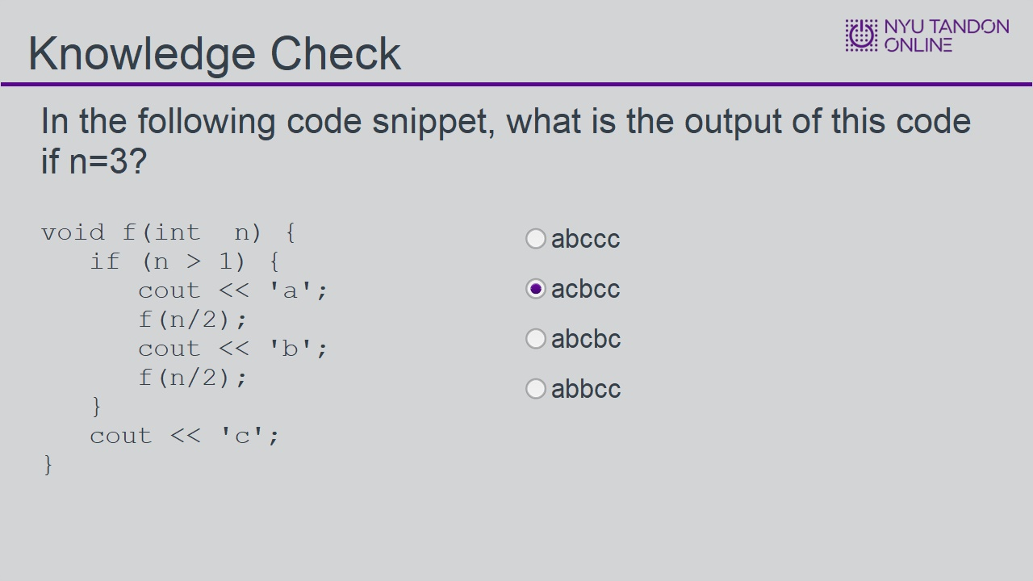
Correct | Choice | Feedback
 | abccc | Note that the first recursive call will finish before the initial call!
X | acbcc | Correct!
 | abcbc | Since n=3, the code would not reach the line “cout<<b” more than once!
 | abbcc | Since n=3, the code would not reach the line “cout<<b” more than once!

Notes:

abccc (Slide Layer)
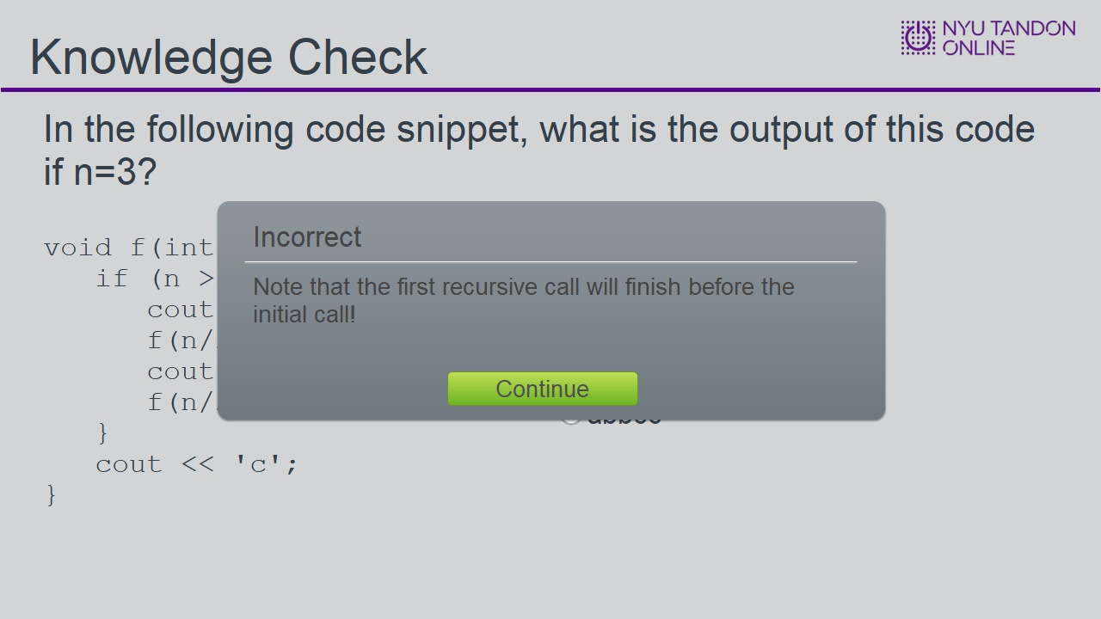

acbcc (Slide Layer)
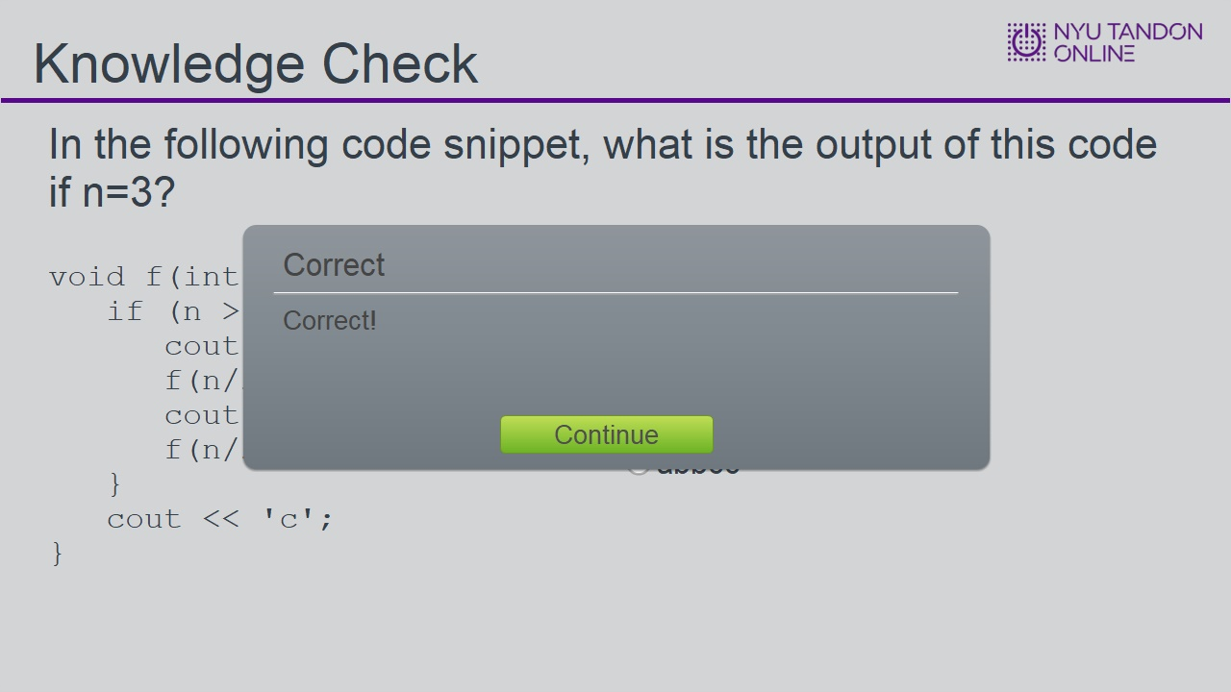

abcbc (Slide Layer)
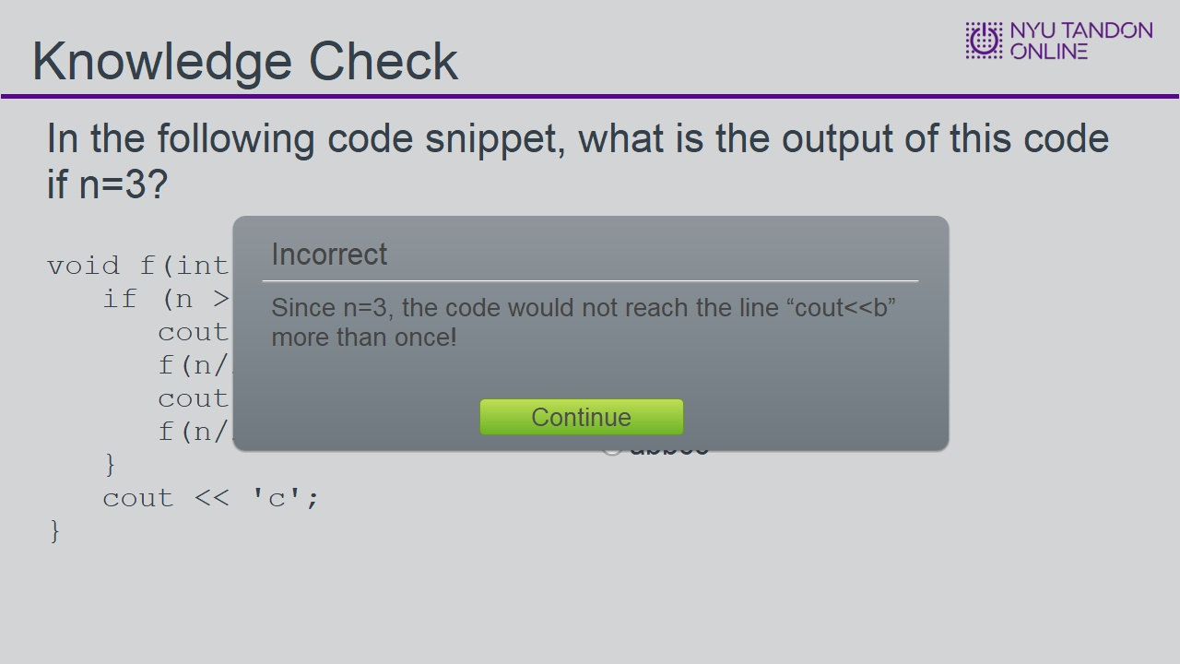

abbcc (Slide Layer)

1.7 End of Module


